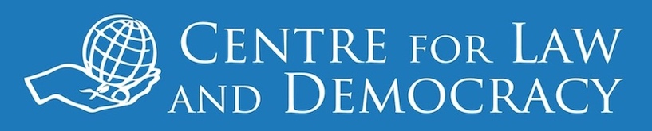



*14 January 2019 – for immediate release*

**Pakistan: Note on Proposed Amendments to Media Regulation**

The Government of Pakistan released a document “Proposed Mandate and Scope of the PMRA” late in 2018. This document is a brief white paper regarding the establishment of a new Pakistan Media Regulatory Authority (PMRA) to regulate all types of media in Pakistan. A Note released today by the Centre for Law and Democracy (CLD) and the Institute for Research, Advocacy and Development (IRADA), based in Pakistan, analyses this policy document, highlighting some of the challenges going forward.

“*It is very welcome that Pakistan is reviewing its rules and systems for regulating the media, which is very important*”, said Toby Mendel, Executive Director of CLD. “*However, the current proposals fail to address, and in some ways even exacerbate, some of the most serious problems with the existing regime.*”

One of the key problems with the new proposals is that they seek to bring not only broadcasting and the print media under one regulator but also the “digital/social media”. This even extends to the idea of having one code of conduct for all of these media sectors. Another serious shortcoming is that even though the statements on the establishment of the regulator are very brief, it is already quite clear that there is no intention to make it independent of government, a key international law requirement in this area.

“*We believe that the government of Pakistan needs to go back to the drawing board and start with an open consultation about what is needed in this area*,” said Muhammad Aftab Alam, Executive Director of IRADA. “*We are willing to work with the government to make sure that the rules are in line with international and constitutional human rights guarantees.*

CLD and IRADA urge the government of Pakistan to put aside their draft document and to host a broad consultation with interested stakeholders on the way forward.

The Note on the Proposed Mandate and Scope of the Pakistan Media Regulatory Authority is available at: <https://drive.google.com/file/d/1S6u8-LCpxSI3GNgJADSeRVtxDqVl2xh8/view>.

***For further information, please contact:***

Toby Mendel

Executive Director

Centre for Law and Democracy

Email: [toby@law-democracy.org](mailto:toby@law-democracy.org)

Tel: +1 902 431-3688

[www.law-democracy.org](http://www.law-democracy.org)

twitter: @law_democracy

Muhammad Aftab Alam

Executive Director

Institute for Research, Advocacy and Development

Email: [ed@irada.org.pk](mailto:ed@irada.org.pk)

+92 321 5959775

[www.irada.org.pk](http://www.irada.org.pk)

twitter: @IRADAPK